Short Questions:

- List briefly and define important factors that can be used in evaluating or comparing the various digital-to-digital encoding techniques.
- What is differential encoding?
- Explain the difference between NRZ-L and NRZI
- Describe two multi level binary digital-to-digital encoding techniques.
- Define biphase encoding and describe two biphase encoding techniques.
- Explain the function of scrambling in the context of digital-to-digital encoding techniques.
- What function does a modem perform?
- How are binary values represented in amplitude shift keying, and what is the limitation of this approach?
- What is the difference between QPSK and offset OPSK?
- What is QAM?
- What does the sampling theorem tell us concerning the rate of sampling required for an analog signal?
- What are the differences amount angle modulation, PM, and FM.

Problems:

- For the bit stream 01001110, sketch the waveform for each of the following codecs:-
NRZ-L, NRZI, Bipolar AMI, Pseudoternary, Manchester, Differential Manchester, B8ZS and HDB3. Assume that the signal level for the preceding bit for NRZI was high, the most recent preceding bit (AMI) has a negative voltage; and the most recent preceding 0 bit (pseudoternary) has a negative voltage.

- Consider a stream of binary data consisting of a long sequence of 1s followed by a zero followed by a long string of 1s, with the same assumptions as problem 1. Draw the waveform for this sequence using
  - NRZ-L
  - Bipolar-AMI
  - Pseudoternary
- Given the pattern 01100, encode the data using ASK, BFSK and BPSK.
- Why should PCM be preferable to DM for encoding analog signals that represent digital data?
- A signal is quantised using 10-bit PCM. Find the signal-to quantisation noise ratio.
- The analog waveform shown in Figure 2 is to be delta modulated. The sampling period and step size are indicated by the grid on the figure. The first DM output and the staircase function for this period are also shown. Show the rest of the staircase function and give the DM output. Indicate regions where slope overload and distortion exists.
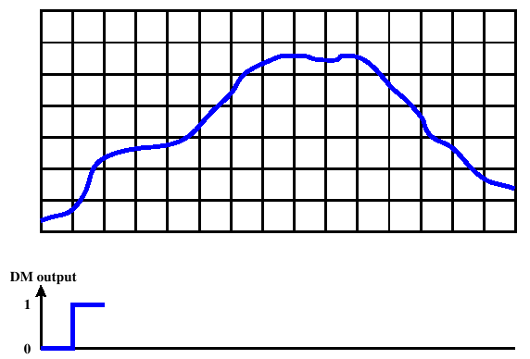Figure 1: Delta Modulation Example
Answers:

Short Questions

- Signal spectrum: A lack of high-frequency components means that less bandwidth is required for transmission. In addition, lack of a direct-current (dc) component means that ac coupling via transformer is possible. The magnitude of the effects of signal distortion and interference depend on the spectral properties of the transmitted signal. Clocking: Encoding can be used to synchronize the transmitter and receiver. Error detection: It is useful to have some error detection capability built into the physical signaling encoding scheme. Signal interference and noise immunity: Certain codes exhibit superior performance in the presence of noise. Cost and complexity: The higher the signaling rate to achieve a given data rate, the greater the cost. Some codes require a signaling rate that is in fact greater than the actual data rate.
- In differential encoding, the signal is decoded by comparing the polarity of adjacent signal elements rather than determining the absolute value of a signal element.
- Non return-to-zero-level (NRZ-L) is a data encoding scheme in which a negative voltage is used to represent binary one and a positive voltage is used to represent binary zero. As with NRZ-L, NRZI maintains a constant voltage pulse for the duration of a bit time. The data themselves are encoded as the presence or absence of a signal transition at the beginning of the bit time. A transition (low to high or high to low) at the beginning of a bit time denotes a binary 1 for that bit time; no transition indicates a binary 0.
- For bipolar-AMI scheme, a binary 0 is represented by no line signal, and a binary 1 is represented by a positive or negative pulse. The binary 1 pulses must alternate in polarity. For pseudoternary, a binary 1 a is represented by the absence of a line signal, and a binary 0 by alternating positive and negative pulses.

- In a scrambling technique, sequences that would result in a constant voltage level on the line are replaced by filling sequences that will provide sufficient transitions for the receiver's clock to maintain synchronization. The filling sequence must be recognized by the receiver and replaced with the original data sequence. The filling sequence is the same length as the original sequence, so there is no data rate penalty.
- A modem converts digital information into an analog signal, and conversely.
- With amplitude-shift keying, binary values are represented by two different amplitudes of carrier frequencies. This approach is susceptible to sudden gain changes and is rather inefficient.

- QAM takes advantage of the fact that it is possible to send two different signals simultaneously on the same carrier frequency, by using two copies of the carrier frequency, one shifted by 90˚ with respect to the other. For QAM, each carrier is ASK modulated.
- The sampling rate must be higher than twice the highest signal frequency.
- Frequency modulation (FM) and phase modulation (PM) are special cases of angle modulation. For PM, the phase is proportional to the modulating signal. For FM, the derivative of the phase is proportional to the modulating signal.

Problems
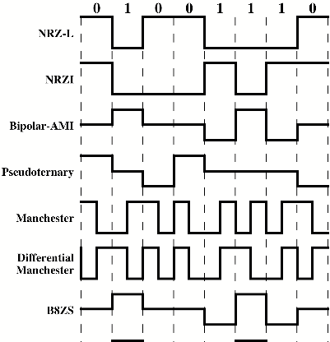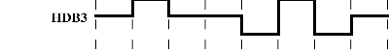

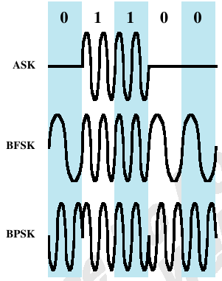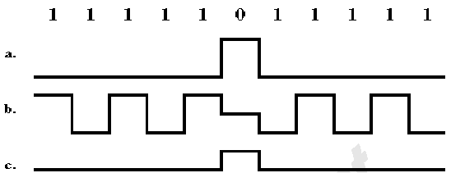

Analog signals in the voice band that represent digital data have more high frequency components than analog voice signals. These higher components cause the signal to change more rapidly over time. Hence, DM will suffer from a high level of slope overload noise. PCM, on the other hand, does not estimate changes in signals, but rather the absolute value of the signal, and is less affected than DM.

- From the text, (SNR)_{db} = 6.02 n + 1.76, where n is the number of bits used for quantization. In this case, (SNR)_{db} = 60.2 + 1.76 = 61.96 dB.
